**Z-test for difference of proportions**

H0: Pc - Pa = 0

Ha: Pc - Pa ≠ 0

α = 0.01

Where Pc is the proportion of Caucasians that are categorized as “high risk” and Pa is the proportion of African Americans categorized as “high risk”, and Pco will be the combined rate.

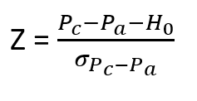

Our Z-score is given by

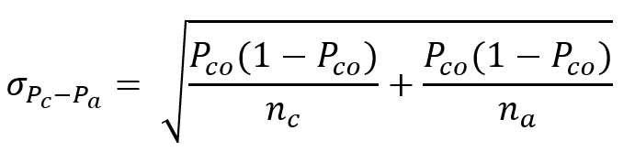

And

Where nc and na are the total number of people in our Caucasian and African American samples, respectively. To obtain our proportions and n values, we reference the outputs from our code:

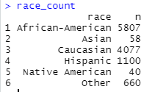

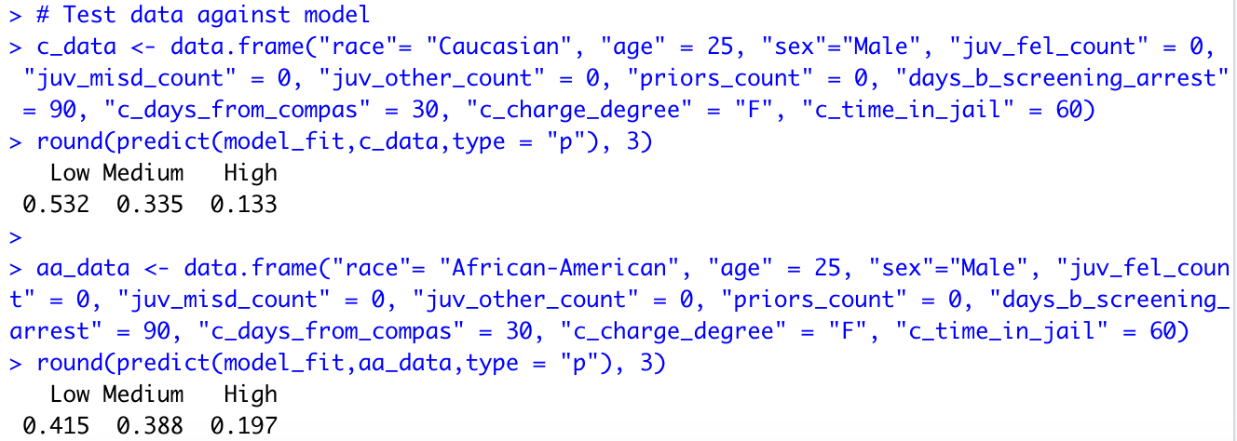

Using the total n-values for each group and these proportions, we can derive our n-values:

|  |  |  |  |
| --- | --- | --- | --- |
|  | Caucasian | African American | Combined |
| Low/Medium risk | 3535 | 4663 | 8198 |
| High risk | 542 | 1144 | 1686 |
| Total | 4077 | 5807 | 9884 |

Thus

Pc = 0.133

Pa = 0.197

Pco = 1686/9884 = 0.1706

nc = 4077

na = 5807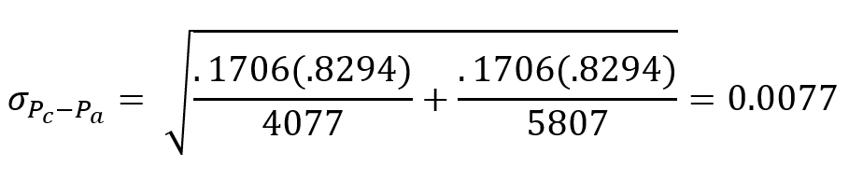

We calculate

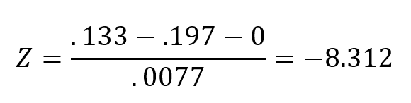

And our Z-score is

With a P-value $≈0$, we reject H0

Therefore we can conclude that there is a statistically significant difference in the rates at which Caucasians and African Americans are being categorized as high-risk.